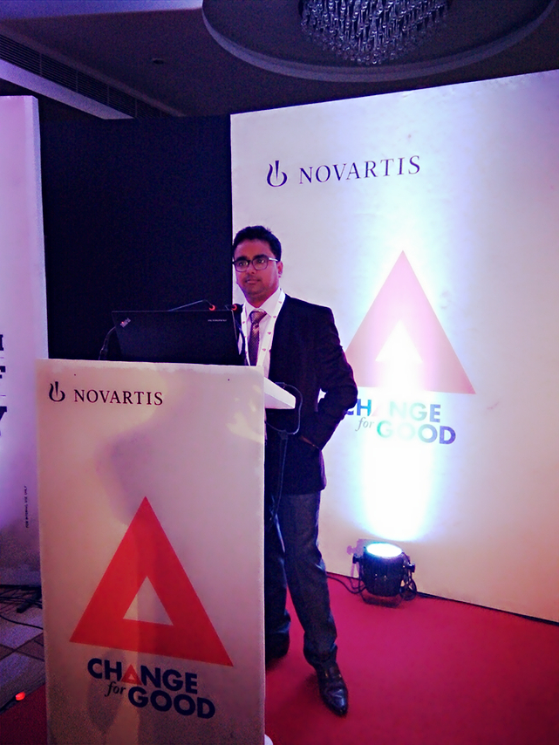

**Sayantan Chatterjee**

**Phone: (M)** +91 8389892192

**Email:** chtsym89@gmail.com / chtsyn89@gmail.com

# Panduah,Mondalai,Hooghly,712146, India

**A seasoned professional with over 2 years of commendable success in Sales and Marketing**

**Core Strengths**

**___________________________________________________________________________________**

*Business Development Promotions and campaigns Channel Management*

*People Management Key account Management Merchandising*

*P & L accountability Relationship Management BTL activities*

**_______________________________________________________________________________________________________**

**Employment History**

***Channel Sales and Marketing Executive,Novartis India Ltd.(Bone and Pain ,Gynae Division)***

***(July 2016)***

* Reporting to ZBM East zone (West Bengal and Guwahati).
* 3 districts covering in West Bengal including Burdwan, Birbhum and Hooghly.
* Promotion of products by meeting with potential KOLs and Stockists.
* Make available of our products in all channels through effective secondary, primary planning.
* Every 3 months doing effective survey (qualitative and quantitative) of the market to expand our market and to know who are our actual buyers.
* Planning and execution of targets every month**.**

**Executive - Market Execution, COCA COLA , Kolkata (March’04,2015 –June'04,2016 )**

**Significant Highlights:**

* Responsible for ensuring RED (Right Execution Daily) at all channel levels to Optimize brand and SKU availability
* Plan and execute all BTL activities at prime 17000 RED outlets of Plant areas contributing 83% of annual sales volume
* Planned marketing activities as per allocated budgets through schemes, branding, activation, merchandising elements.
* From every month AC Nielsen survey report planning and implementing the findings at each retail outlet score , aiming at increasing market share, numeric distribution and deft of the distribution
* Ensure execution and activation of brand programs, community programs and brand building activities
* Identify opportunities by analyzing consumer requirements, defining market / competitor's share and competitor's strengths & weaknesses.

**Summer Intern- Coca-cola , Hooghly ( May 2014 - August 2014)**

* Appointing Dealers and Sub-dealers at rural area of Hooghly District.
* Generated Primary and secondary through effective product launch.
* Set up the Rural and urban distribution network
* Managed Warehouse inventory level.

**Academic Details**

* **MBA in Marketing and System 2 years full time** from **Institute of Engineering and Management** (Recognized by AICTE) with 6.79 DGPA (2013-2015)
* **Bachelor of Science, Biotechnology** from WBUT with 63% (2006-2009)
* **Brand and Product Management** from **IE Business School via Coursera**
* **H.S with Pure Science (Physics,Chemistry,Mathemetics**) with 55%
* Computer Profiency - Ms Office,Photoshop,HTML,SEO.

**Personal Vitae**

**Date of Birth**: 3rd January, 1989

**Linguistic Proficiency:** English, Hindi and Bengali

**Nationality:** Indian

**Father’s Name :** Shyamal Chatterjee

**Marital Status :**  Single

Thank You with Regards

Sayantan Chatterjee